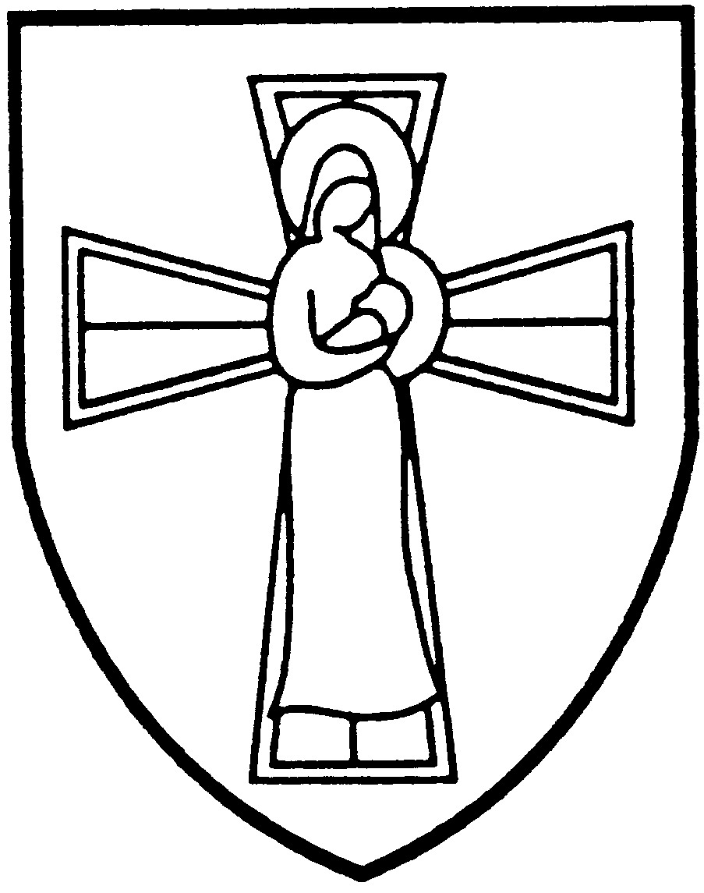

St Mary's Catholic Primary School
Educate Protect Love Serve

Barn Lane, Bodmin, Cornwall, PL31 1LW
Tel: 01208 73218
Executive Headteacher: Mrs Alison McDonald
Website: www.st-marys-bod.cornwall.sch.uk
Twitter @StMarysBodmin
_________________________________________________________________________________________

The Governors of St Mary’s Catholic Primary School, Bodmin are seeking to appoint a positive and inspiring Administrative Assistant. They are keen to accommodate the best candidates who will make a positive impact on our school and standards. Applicants with experience are encouraged to apply.
We offer:
- A welcoming school with a strong Catholic ethos
- Children who are polite, happy and motivated to learn
- A supportive staff team who genuinely want the best for our pupils
- A commitment to your own professional development
The successful candidate will:
- Be happy to support the Catholic ethos of our school
- Be committed to creating challenge, excitement, creativity and independence in learning
- Be dedicated to raising standards and be a good role model
- Have excellent organisational and communication skills
- Be dynamic, resilient and hard working with a positive nature
- Be able to work as part of a team and establish positive relationships with pupils, parents, governors and staff
- Have a reflective and evaluative approach to their practice
Required Date; As soon as possible
Salary: £20812- £21968 (FTE)
Contract: Permanent position of 25 hours per week
Visits to the school are encouraged. To arrange a visit, please contact the school on 01208 73218.

We are committed to safeguarding and promoting the welfare of children and young people and expect all staff and volunteers to share this commitment. An enhanced DBS Disclosure is required for this post.
Closing Date: 21th April 2023
Interviews: week commencing the 24th April 2023(TBC)
Please send your completed applications to administrator@st-marys-bod.cornwall.sch.uk
Shortlisted candidates will be notified by email

