RE Yearly Overview – Programme of Study for Year 4
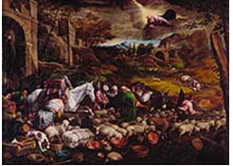
Creation
Children will explore the concept of ‘image and likeness of God’, and because God is in all of us, we are called to respect and value our similarities and differences. Through the knowledge of the Jewish faith, the children will explore the skills of reverence and respect and reflect on how to apply these in their own lives of faith. Artefacts of Judaism are explored in the multi-faith element.
Prayers, Saints and Feasts
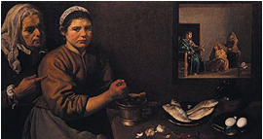
Children will learn about the prayer life of Jesus and how he grew up in the Jewish faith. The children will be introduced to some prayers of the Old Testament and reflect on the importance that Jesus attached to prayer and how he taught his followers to pray. The children will also reflect on the importance of prayers to Mary in the life of the church and research the history of the Rosary. Children also learn through the Islamic faith and the importance of prayers in other religions.
Advent
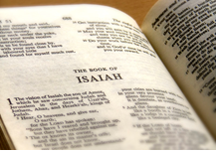
To deepen children’s understanding of what God promised when he promised to send his son. The ancestry of Jesus is explored to enable a deeper understanding of the nature of the Messiah. The meaning behind some of the titles and names given to Jesus are explored (such as Messiah and Emmanuel), and the role of the prophets who help prepare us for the presence of Jesus.
Christmas
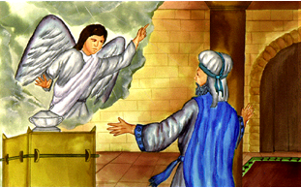
The children examine the role of the angels in the Christmas story and to identify ways in which we can be messengers of the Good News today. The children explore the feasts that are associated with Christmas, such as the Annunciation and the birth of John the Baptist. Ways in which the parish community celebrates Christmas are also identified.
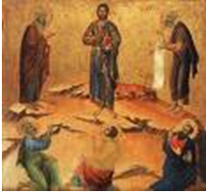
Revelation
The children are asked to consider two examples of God’s revelation of himself in Jesus. In the Presentation, the revelation of God is recognised by Simeon and Anna and in the Transfiguration, the disciples respond with fear but beheld his glory. Consideration is also given to the symbolism of light and why this symbol is important. In the multi-faith element, the origins of the Sikh religion and their celebrations of light over darkness are considered.
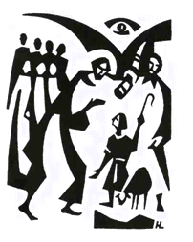
Sacraments
Children will explore the nature of vocation and its symbolism in preparation for work on the sacraments of vocation in year 5. This is done through Old Testament stories which show how God calls people in faith and the symbolism of anointing.
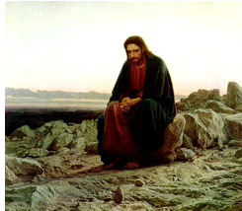
Lent
Children will build upon their previous understanding of forgiveness and penance, with a focus on the Temptation of Jesus. Children will develop and explore how payer, fasting, almsgiving and living out the Beatitudes help us prepare for Easter. In the multi-faith element, children examine Yom Kippur (holiest day in Judaism).

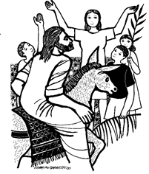
Holy Week
Children will explore the events of Holy Week with a focus on the change in mood that occurred from the events of Palm Sunday to the crucifixion of Jesus on Good Friday. Children will understand the role of the Pharisees, and the positive role they played in Jewish society, and that it was only ‘some Pharisees’, along with other people, who disliked Jesus.
Easter
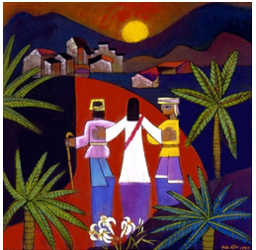
Children will focus on the appearances of Jesus with an explanation of the road to Emmaus story. They will be introduced to and examine the Ascension and what it teaches us. The Hindu festival of Divali is explored in the multi-faith element.

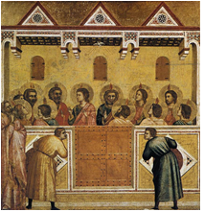
Pentecost and Mission
Children will explore the ‘handing on of faith’ through the work of the apostles, saints and ourselves. The nature of the Holy Spirit is explored and identified in Scripture, which should develop an understanding of what this means in their own lives.

